Week 6 – Stocks and Bonds

Stock valuation
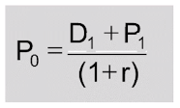
- Calculating price of a share by obtains the present value of next years dividend and its share price

Dividend discount model
- Zero growth scenario is a simple perpetuity:

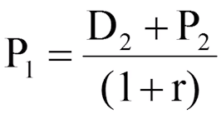
- How to calculate P1 if not given:

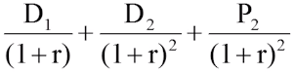
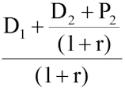
- Therefore P₀ =

- P₀ = summation from t = 1 to infinity of future dividends

Variation on the dividend discount model
- Constant growth: dividend growth model / growing perpetuity model:
  - r is required rate of return / cost of equity / market capitalisation
  - g is the sustainable growth rate of the firm
  - r > g otherwise. g is not constant per se, but the average growth of dividends
  - Also known as the Gordon-Shapiro Model
- Non-constant growth:
  - PV of dividends from year 1 to year n:
$$\frac{D_{1}}{r-g}[{\left(1- \frac{1+g}{1+r}\right)}^{n}]$$
    - Don’t use where g > r
  - PV of share price in year n (using perpetuity, n+1 year’s dividend)
$$\frac{D_{n+1}}{r {\left(1+r\right)}^{n}}$$
    - Basically you’re calculating a perpetuity from year n t infinity, and this is discounted back to the year n-1 to assess its value at that time.
NB – question 7aii 2019, company pays out all earnings as dividends from year 5, so D5 is actually earnings per share in year 5, not dividends per share

Price-to-earnings ratio is a valuation method showing share price relative to earnings per share.
    - Shows an investor how many pounds they must invest to receive back one pound of the company’s earnings
    - Anticipated growth rate can be determined by multiplying return on equity by retention ratio (g = ROE X RR)
    - Calculate dividend per share in year 1 by multiplying earnings per share by the pay-out ratio of the firm (1 – retention ratio)
    - Then calculate share price using a constant growth dividend discount model

Bond valuation
- Long term loans with repayments (cash flows)
  - Maturity date is a set future date when the bond is repaid
  - Face value – amount issuer promises to pay on maturity date
  - Coupon – periodic interest payments made until maturity
  - Coupon rate – annual interest rate paid to the holder until maturity date
  - YTM – annual return expected if you hold bond until the maturity
  - Redemption value is the amount repaid at maturity (usually equal to face value to bond was purchased for)
    - At par: FV = RV
    - Above par: FV < RV
    - Below par: FV > RV
  - Conventional bonds pay a regular cashflow throughout the bond’s duration, then repay a capital sum
  - Zero-coupon bonds pay no regular capital, only the redemption value

Fair value of a bond
- Discount all cashflows the debt security generates (coupons and face value)
  - c = Coupon
  - F = Face value
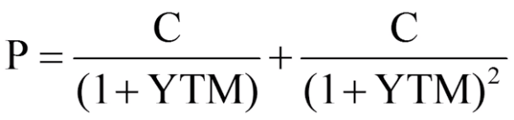
  - YTM = yield to maturity
- FV is how much we should pay for the bond
$$P_{0}= \frac{C}{YTM}x \left(1-\frac{1}{{\left(1+YTM\right)}^{t}}\right)+ \frac{FV}{{\left(1+YTM\right)}^{t}}$$

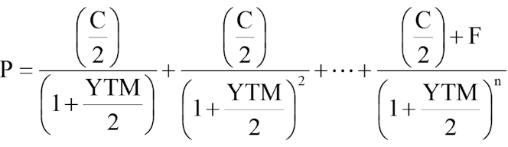
Semi-annual coupons

Concept of yields
$$\frac{FV}{{\left(1+YTM\right)}^{t}}$$

